How to add server-side file storage and sharing

Part 1 – Add new DB to MongoDB and add to the Node.js server
- Go to your Node.js server code, open a new terminal and run the command:
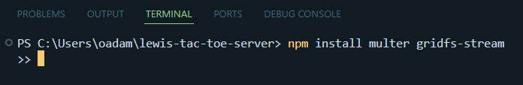
- Open index.js in the server code and add in these imports after your existing imports from the previous level’s code:
const multer = require('multer');
const { GridFSBucket } = require('mongodb');
const { Readable } = require('stream');

- Add in this after let db;
let gfsBucket;

and then add the highlighted portions:
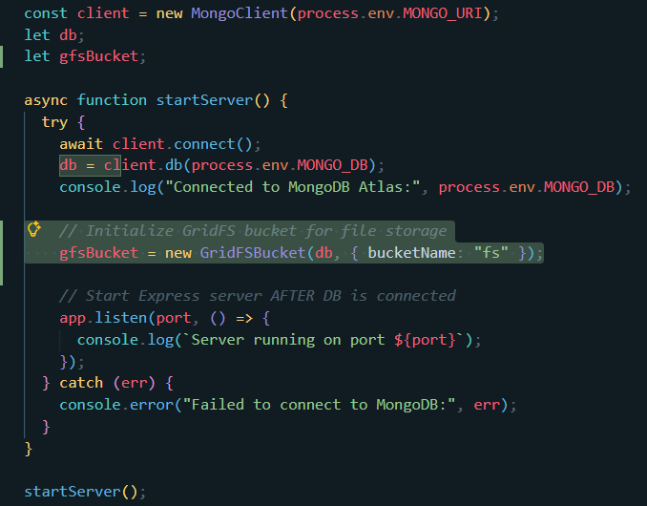
- Now we need to set up multer for file uploads so place these lines near the top after the middleware
const storage = multer.memoryStorage();
const upload = multer({ storage });

- Then under the other API routes like /api/log-login and /api/logins, add in some new routes for uploading:
// Upload a file
app.post('/api/upload', upload.single('file'), async (req, res) => {
if (!req.file) return res.status(400).json({ error: "No file uploaded" });

const readableFile = new Readable();
readableFile.push(req.file.buffer);
readableFile.push(null);

const uploadStream = gfsBucket.openUploadStream(req.file.originalname, {
metadata: { uploadedBy: req.body.email || "anonymous" }
});

readableFile.pipe(uploadStream)
.on('error', (err) => {
console.error(err);
res.status(500).json({ error: "Upload failed" });
})
.on('finish', () => {
res.json({ message: "File uploaded successfully", fileId: uploadStream.id });
});
});

- And then add one route for downloading:
// Download a file by filename
app.get('/api/files/:filename', async (req, res) => {
try {
const file = await db.collection("fs.files").findOne({ filename: req.params.filename });
if (!file) return res.status(404).json({ error: "File not found" });

res.setHeader("Content-Disposition", `attachment; filename="${file.filename}"`);
const downloadStream = gfsBucket.openDownloadStreamByName(req.params.filename);
downloadStream.pipe(res);
} catch (err) {
console.error(err);
res.status(500).json({ error: "Failed to download file" });
}
});

- Then we also want to add another route for listing the files:
// List all files
app.get('/api/files', async (req, res) => {
try {
const files = await db.collection("fs.files").find().toArray();
res.json(files);
} catch (err) {
console.error(err);
res.status(500).json({ error: "Failed to list files" });
}
});

Part 2 – Adding to the React web application code
- Open up the code for your React web app and then create a new file called FileManager.js in the src folder and put this code inside it:

import React, { useState, useEffect } from "react";

export default function FileManager({ user }) {
const [selectedFile, setSelectedFile] = useState(null);
const [files, setFiles] = useState([]);

// Handle file input changes
function handleFileChange(e) {
setSelectedFile(e.target.files[0]);
}

// Upload selected file
async function handleUpload() {
if (!selectedFile) return alert("No file selected");

const formData = new FormData();
formData.append("file", selectedFile);
formData.append("email", user.email); // optional metadata

try {
const res = await fetch(
"https://lewis-tac-toe-server.azurewebsites.net/api/upload",
{
method: "POST",
body: formData,
}
);
const data = await res.json();
if (res.ok) {
alert("File uploaded successfully!");
setSelectedFile(null);
loadFiles();
} else {
alert("Upload failed: " + data.error);
}
} catch (err) {
console.error(err);
alert("Upload error");
}
}

// Load files from server
async function loadFiles() {
try {
const res = await fetch(
"https://lewis-tac-toe-server.azurewebsites.net/api/files"
);
const data = await res.json();
setFiles(data);
} catch (err) {
console.error(err);
}
}

useEffect(() => {
loadFiles();
}, []);

return (
<div className="file-manager">
<h2>File Manager</h2>

<input type="file" onChange={handleFileChange} />
<button onClick={handleUpload}>Upload</button>

<h3>Uploaded Files:</h3>
<ul>
{files.length > 0 ? (
files.map((file) => (
<li key={file._id}>
{file.filename}{" "}
<a
href={`https://lewis-tac-toe-server.azurewebsites.net/api/files/${file.filename}`}
download
>
Download
</a>
</li>
))
) : (
<li>No files uploaded yet.</li>
)}
</ul>
</div>
);
}

- Then, open the App.js file and add this import at the top:
import FileManager from "./FileManager";

Then near the bottom, add this line:
{isAuthenticated && <FileManager user={user} />}
Which should go after the other line above it that looks just like it, but uses PlayerStats stats={stats} instead

Part 3 – Let’s do some testing!
- To start with local testing, make sure you go back and replace any web address in the code you see that is currently https://lewis-tac-toe-server.azurewebsites.net to http://localhost:3000
- Then make sure you open your server code’s terminal and type npm start which should default it to port 3000. Then do the same for your client/react app’s code which should default it to port 3001. Then go and see the changes. At this point, you should be able to login, authenticate, and then if you scroll down, it should allow you to upload a file from your computer, and then send it through to MongoDB and then you should soon see the file name you uploaded and a download link if you want to download it.
- If everything looks good on the local side, make sure you just revert step 1 and put back the name of your server site without neglecting any of the routes like /api/logins for example and then push the changes through source control for both the server and the client/react app and then you should be good to go if everything looks good in production!

